Module 4 (Task 2)

Task A (Insert): Write the MongoDB command to insert a new podcast document.
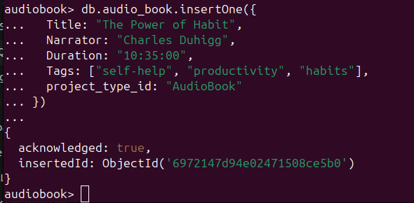
I added new AudioBook Data Using Insert Query

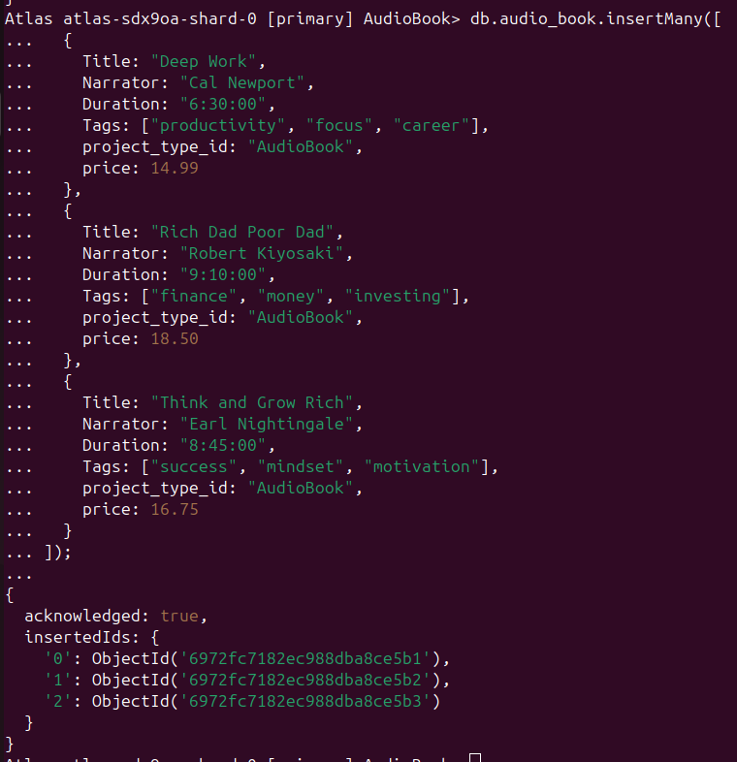
here added another Audio Book using insertMany:-

Task B (Find): Write the command to find all assets where Duration is greater than 60 minutes.

Because Duration is a STRING
MongoDB cannot correctly compare "3:27:00" with 60 directly.

Here I write query to fetch 10 audioBook which has duration more then 60 min.

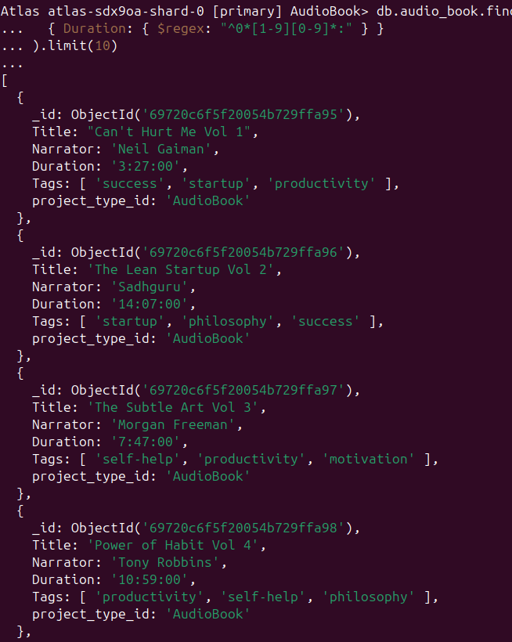

In this task, the query filters only those audiobooks whose duration is less than 5 hours.

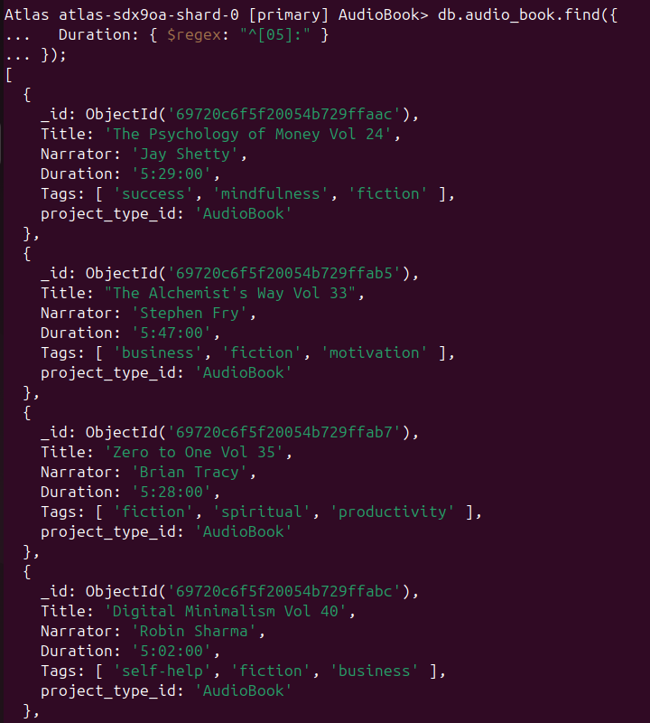

Task C (Projection): Find all documents but only return the Title field (hide the _id).

This Query give only Title From collection
Just like Select (particular column)

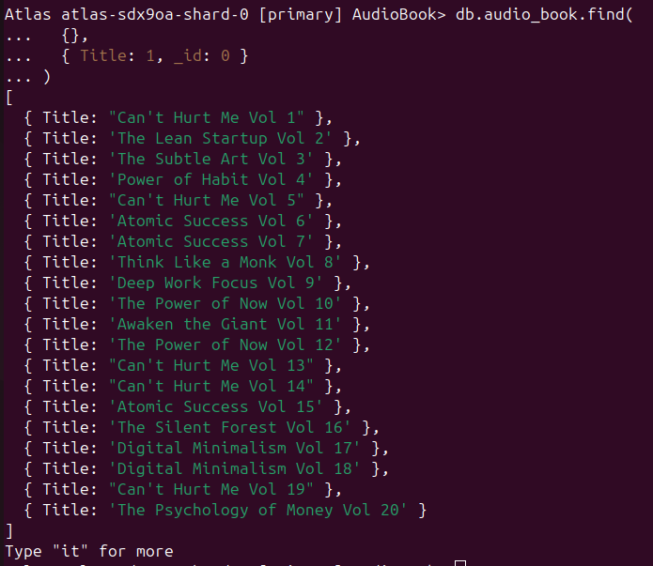

In this task, this query returns the title and narrator.

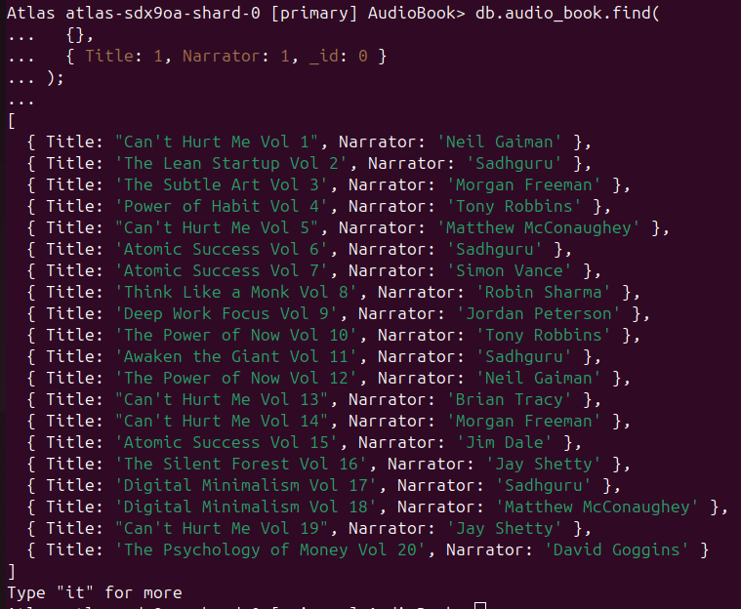

Here, this query returns books whose price is less than 18.
